BSCS FINAL PROJECT
Requirements Specification

Family Digital Heritage Vault



Project Advisor

Ms. Mahrukh Batool

Presented by:
Group ID: F25CS171

Student Reg# Student Name
L1F22BSCS0394 Shazam Javed
L1F22BSCS1045 Khubabib-ul-Hassan
L1F21BSCS0360 Abdullah Amir

Faculty of Information Technology & Computer Science

University of Central Punjab

Software Requirements Specification

Version # 1

Family Digital Heritage Vault

Advisor: Ms. Marukh Batool

Group F25CS171
Member Name | Primary Responsibility
Shazam Javed | Quality, Testing & Research Lead (Plus Support Dev)
Khubaib-ul-Hussain | Mobile App & UI/UX Lead
Muhammad Abdullah | Project Manager & Backend Lead

Table of Contents
Abstract 1
1. Introduction and Background 1
1.1 Product (Problem Statement) 1
1.2 Background 2
1.3 Scope 3
1.4 Objective(s)/Aim(s)/Target(s) 3
1.5 Challenges 4
1.6 Learning Outcomes 5
1.7 Nature of End Product 5
1.8 Completeness Criteria 6
1.9 Business Goals 6
1.10 Related Work/ Literature Survey/ Literature Review 7
1.11 Document Conventions 7
2. Overall Description 8
2.1 Product Features 8
2.2 User Classes and Characteristics 9
2.3 Operating Environment 9
2.4 Design and Implementation Constraints 10
2.5 Assumptions and Dependencies 10
3. Functional Requirements 11
3.1 Register & Create Family Vault 12
3.2 Login to Existing Family Vault 12
3.3 Add Family Member to Family Tree 13
3.4 View Family Tree 14
3.5 Upload Memory (Photo/Video/Audio/Text) 14
3.6 View Memory with Access Control 15
3.7 Configure Inheritance Rules 15
3.8 Search & Filter Memories 16
3.9 Edit User Profile & Enable Biometric Login 17
3.10 Requirements Analysis and Modeling 17
3.10.1 Entity Relationship Diagram 17
3.10.2 Abstract Class Diagram 18
3.10.3 Enhanced Sequence Diagram 20
3.10.4 State Diagram 21
3.10.5 Data Flow Diagram (DFD Level 0) 22
3.10.6 Data Flow Diagram (DFD Level 1) 22
4. Nonfunctional Requirements 23
4.1 Performance Requirements 23
4.2 Safety Requirements 23
4.3 Security Requirements 23
4.4 Additional Software Quality Attributes 24
5. Other Requirements 24
6. Revised Project Plan 25
6.1 Project Initiation: 25
6.2 Requirement Analysis and System Design: 25
6.3 Backend Development (Node.js + MongoDB): 25
6.4 Frontend Development (Flutter App): 25
6.5 Integration and Testing: 25
6.6 Deployment and Final Presentation: 25
7. References 26
8. Appendix A: Glossary 27
8.1 Key Terms and Definitions: 27
9. Appendix B: IV & V Report 29

Revision History
Name | Date | Reason For Changes | Version

Previous Phases Feedback

Idea Defence Feedback (Screenshot)

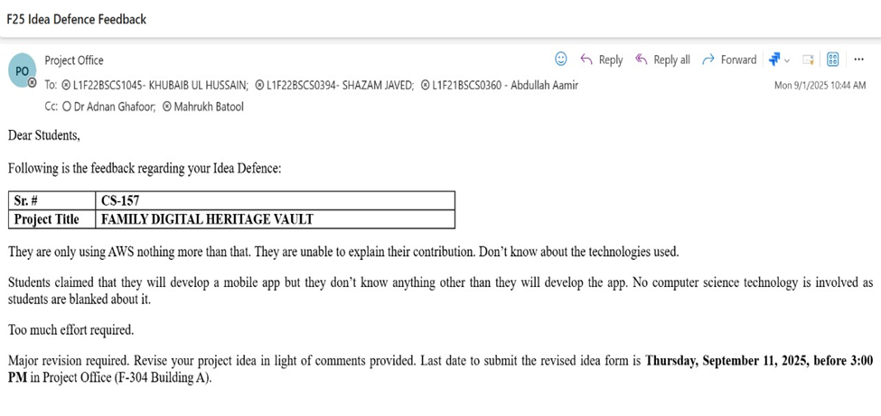

Abstract
The Family Digital Heritage Vault is a mobile-based, cloud-backed software system designed to help families preserve, organize, and pass down their digital memories and values across multiple generations. Modern families generate a large volume of digital content, including photographs, videos, audio notes, and written messages, yet this content is often scattered across personal devices, social media platforms, and generic cloud storage solutions. As a result, memories become fragmented, difficult to retrieve, and vulnerable to permanent loss due to device failures, account deactivation, or poor organization.
This project proposes a dedicated solution that treats family memories as long-term digital assets that can be securely stored and meaningfully inherited. The system provides a family vault associated with a visual family tree, where each member’s profile can be linked to specific memories, stories, and personal messages. A key feature of the system is heir-based access control and configurable inheritance rules, enabling content owners to define who can see which memories and under what conditions (e.g., after a certain age or on specific life events). The application will be developed using Flutter for cross-platform mobile front-end, Node.js and MongoDB for backend services and data management, and Firebase for authentication and notifications.
The expected outcome is a functional prototype capable of demonstrating registration and login, family vault creation, family tree visualization, multimedia upload, inheritance configuration, and memory browsing under secure access rules. Beyond its academic value, the project has long-term potential as a commercial digital legacy platform that supports cultural preservation and intergenerational emotional bonding.

Introduction and Background
The emergence of digital technologies has fundamentally changed how families create, store, and share their memories. Traditionally, family heritage was preserved through physical photo albums, handwritten letters, diaries, and oral storytelling across generations. In contrast, today’s families rely heavily on smartphones, social media platforms, and cloud services. While these tools provide convenience and instant communication, they are not designed for structured, long-term, intergenerational preservation of memories.
Digital content stored in personal accounts is at constant risk of being lost or becoming inaccessible. Passwords may be forgotten, accounts may be disabled, or services may change their policies. Social media timelines are cluttered, noisy, and controlled by external platforms with their own priorities and algorithms. In addition, there is rarely any systematic way to ensure that future generations receive access to specific meaningful content in a private and emotionally appropriate manner.
The Family Digital Heritage Vault project addresses this gap by proposing a specialized platform dedicated to preserving family memories as long-term digital heritage. Instead of treating files as isolated objects, the system organizes them around a family structure and life events, emphasizing relationships and emotional context. This introduction explains the problem, background, scope, objectives, challenges, and desired outcomes that guide the system’s requirements.

Product (Problem Statement)
Despite the abundance of digital tools, families face the following issues:
- Memories are scattered across multiple devices and platforms.
- There is no simple way to associate memories with specific family members or generations.
- Sensitive or deeply personal content may need to be revealed only at certain times or to particular individuals.
- Existing platforms are not optimized for long-term digital inheritance or structured storytelling.
The central problem this project aims to solve is:
How can we provide families with a secure, user-friendly, and intergenerational digital vault that organizes multimedia memories around a family tree and supports inheritance-based access rules to preserve and pass on family heritage over time?
The product, Family Digital Heritage Vault, is conceived as a dedicated solution that goes beyond generic file storage by offering family-centric organization, inheritance-aware access control, and emotional storytelling features.

Background
The background of this project lies at the intersection of several domains:
- Digital Legacy Management
As more aspects of life move online, individuals leave behind a “digital footprint” consisting of social media accounts, emails, digital photos, and other data. Digital legacy management is concerned with how this data is preserved, accessed, or deleted after a person dies. Current solutions in this domain are largely focused on account control or data transfer but rarely offer structured, family-centric storytelling.
- Genealogy and Family History
Many families have an interest in tracing their ancestry and documenting their family history. Existing genealogy platforms provide tools for constructing family trees and storing basic records such as names, dates, and life events. However, they often do not integrate rich multimedia content or personalized emotional messages in a secure and controlled environment.
- Cloud Storage and social media
Cloud services such as Google Drive or Dropbox provide reliable file storage, while social media platforms like Facebook or Instagram allow sharing of everyday life moments. However, these tools are not designed for intergenerational narrative building, inheritance rules, or fine-grained family-based access control. They also pose privacy risks and are subject to external policies.
The Family Digital Heritage Vault aims to combine advantages from all these domains: the longevity and reliability of cloud storage, the structural clarity of genealogy systems, and the emotional richness of social media content, while mitigating their limitations and aligning everything around the specific needs of families.

Scope
The scope of the project defines what is included and excluded in the FYP implementation.
In-Scope:
- Development of a mobile application (primarily targeting Android, with potential support for iOS).
- Implementation of a backend service using Node.js and MongoDB that exposes RESTful APIs.
- Integration of Firebase Authentication for secure, reliable user identity management.
- Design and implementation of:
  - A family vault tied to a primary administrator.
  - A family tree visualizer for representing family members and relationships.
  - Multimedia memory management (photos, short videos, audio messages, text notes).
  - Heir-based access control and inheritance rules for memories.
  - Event-based digital cards and notifications for birthdays, anniversaries, and similar occasions.
- Support for basic search and filtering of memories by tags, dates, and associated family members.
- Production of complete documentation including RS-1, RS-2 (later), design artifacts, implementation details, testing reports, and user manual.
Out-of-Scope (for FYP timeframe):
- Full web-based front-end for desktop browsers.
- Advanced AI features such as facial recognition, automatic tagging, or auto-generated memory highlights.
- Legal integration with actual wills, lawyers, or official digital estate services.
- Very large-scale optimization for millions of users (only moderate scalability will be considered).
- Multi-language localization beyond English in the first version.
By focusing on this defined scope, the team ensures that the project is ambitious yet achievable within the constraints of the FYP duration and available resources.

Objective(s)/Aim(s)/Target(s)
The project has several interconnected objectives:
- Design Objective:
To conceptualize and design a family-centric digital vault architecture that reflects real-world family relationships and supports long-term memory preservation.
- Functional Objective:
To implement core features including user registration, family vault creation, family tree management, memory upload and retrieval, inheritance rule configuration, and event-based notifications.
- Security Objective:
To ensure that access to the system and to individual memories is strictly controlled using authentication and authorization mechanisms, protecting sensitive data against unauthorized access.
- Usability Objective:
To provide an intuitive and accessible user interface that can be comfortably used by both younger and older family members with varying levels of technical expertise.
- Reliability and Performance Objective:
To develop a system that performs efficiently during common operations, handles typical network delays gracefully, and maintains data integrity across all operations.
- Academic Objective:
To apply principles of software engineering, including requirements engineering, architectural design, implementation best practices, testing strategies, and documentation standards, thereby producing a high-quality FYP artifact.

Challenges
Several challenges are expected during the development of the Family Digital Heritage Vault:
- Complexity of Family Relationships:
Modeling diverse family structures (including step-relationships, adoptions, multiple marriages, etc.) in both UI and database in a way that remains intuitive and maintainable.
- Designing Inheritance Rules:
Defining a flexible yet manageable rule system that supports time-based, relationship-based, and event-based conditions, without making it too complicated for normal users to understand.
- User Experience for Non-Technical Users:
Creating a clean and simple interface that hides technical complexity, uses everyday language instead of technical terminology, and supports guided flows.
- Data Security and Privacy:
Handling sensitive personal content responsibly, ensuring encryption in transit, secure credential storage, and appropriate access checks for every protected resource.
- Multimedia Management:
Efficiently handling the upload, storage, and retrieval of multimedia files, while keeping in mind limitations on bandwidth, storage costs, and device capacities.
- Time and Resource Constraints:
Completing a feature-rich system within the FYP timeline using a three-person team, while also balancing academic workload and other responsibilities.
Addressing these challenges requires careful planning, iterative development, and continuous testing and feedback.

Learning Outcomes
By completing this project, the team expects to achieve the following learning outcomes:
- Requirements Engineering Skills:
Ability to gather, analyze, and document functional and non-functional requirements in the form of a structured RS-1 and subsequent documents.
- Technical Implementation Skills:
Practical experience in building a full-stack application, including mobile front-end (Flutter), backend APIs (Node.js), and NoSQL database (MongoDB), integrated with cloud services (Firebase).
- Security and Access Control Knowledge:
Understanding of how to implement authentication, authorization, and secure storage practices in a real-world context.
- System Design and Architecture:
Capability to create and interpret UML and ER diagrams, design modular architectures, and understand trade-offs between different design choices.
- Testing and Quality Assurance Skills:
Experience in designing test cases, performing unit and integration testing, and evaluating usability with sample users.
- Soft Skills:
Improvement in teamwork, project management, communication with supervisors, and preparation of professional documentation and presentations.

Nature of End Product
The end product of this project will be a working prototype of the Family Digital Heritage Vault, not merely a theoretical design. Concretely, the deliverables will include:
- A mobile application that can be installed on Android devices (with a generated APK) and, where possible, tested on iOS emulators or devices.
- A backend server with documented RESTful APIs for user management, vault operations, memory handling, and inheritance rule processing.
- A database instance containing example data for demonstration, including sample families, members, and memories.
- A user manual describing how to install, configure, and use the application.
- A technical report detailing system architecture, data models, design decisions, and testing results.
- A presentation and demonstration prepared for the final evaluation.
Although the prototype will be built on a limited scale, it will be sufficiently complete to demonstrate the concept and to serve as a foundation for future development.

Completeness Criteria
The project will be considered complete when the following criteria are met:
- Functional Completeness:
  - Users can register, log in, and create a family vault.
  - Family administrators can add and manage family members, and build a visual family tree.
  - Users can upload, view, edit (where allowed), and delete multimedia memories.
  - Inheritance rules can be configured and enforced for specific memories.
  - Basic notifications or event-based cards (such as birthday reminders) are generated successfully.
- Non-Functional Compliance:
  - The system meets defined performance thresholds (e.g., acceptable response times).
  - Basic security measures (authentication, HTTPS, hashed passwords) are properly implemented.
  - The interface is usable according to informal user testing feedback.
- Documentation and Testing:
  - All required documents (RS-1, RS-2, design, testing reports, user manual, final report) are completed to a satisfactory standard.
  - Test cases have been executed and defects addressed to a reasonable degree.
- Demonstrability:
  - The team is able to demonstrate all key features during the final presentation, using real or sample data, without major failures.

Business Goals
Although this system is developed primarily as an academic project, it is designed with potential real-world usage and commercialization in mind. Some long-term business goals that could emerge from this project include:
- Subscription-Based Model:
Offering different tiers of storage and features (e.g., free basic plan with limited storage, premium plans with more storage and advanced features).
- Value-Added Services:
Providing additional services such as printable memory books, AI-generated video summaries, or legacy messages that can be scheduled far into the future.
- Partnerships:
Collaborating with organizations, communities, or diaspora groups interested in preserving cultural heritage and family histories.
- White-Label Solutions:
Adapting the platform for specific institutions (e.g., cultural centers, religious organizations) that want customized heritage vaults for their members.
Having clear potential business goals strengthens the justification for the project and increases its relevance beyond the academic context.

Related Work/ Literature Survey/ Literature Review
The literature review examines existing approaches and products in three main categories:
- General Cloud Storage Platforms
Services such as Google Drive, Dropbox, and OneDrive provide robust and scalable storage solutions. They support file sharing, folder organization, and collaboration features. However, they do not provide family-centric views, inheritance rules, or integration with a family tree structure. Files are treated as generic objects rather than emotionally significant memories linked to specific people and relationships.
- Social media and Memory Platforms
Social media sites like Facebook, Instagram, and Snapchat allow users to share everyday moments. Some of them offer “memories” features that resurface old posts. However, these platforms are primarily designed for social interaction and public or semi-public sharing. They are not built around long-term digital legacy or controlled inheritance, and content is heavily tied to the platform’s policies and user accounts.
- Genealogy and Family History Tools
Genealogy websites and family history tools focus on constructing family trees, managing historical records, and tracing lineage. While they may allow the attachment of documents or photos to individuals, their main emphasis is on historical or archival records rather than contemporary multimedia storytelling and secure inheritance workflows.
- Digital Legacy Management Solutions
Some services and research initiatives specifically address digital legacy, focusing on what happens to a person’s digital accounts and data after death. These often involve account transfer, data export, or “digital wills”. However, they rarely provide an integrated interface that combines daily memories, family relationships, and per-memory inheritance rules in an easy-to-use format.
The proposed Family Digital Heritage Vault integrates concepts from all these domains but aims to fill the unique niche of family-centered, multimedia, inheritance-aware heritage preservation. This combination makes it distinct from existing work and provides a strong rationale for its development.

Document Conventions
This RS-1 document uses the following conventions:
- Section headings follow the standard hierarchical numbering scheme (1, 1.1, 1.1.1, etc.).
- Functional Requirements are primarily expressed through Use Cases in Section 3, labeled as UC-1, UC-2, and so on.
- Non-Functional Requirements are grouped in Section 4 and categorized under performance, safety, security, and other quality attributes.
- Important terms such as Vault, Family Tree, Memory, Heir, and Inheritance Rule are defined in the Glossary (Appendix A).
- The term system refers to the complete software product (mobile app + backend + database).
- Where appropriate, bullet lists and tables are used to improve clarity.
- All references to external works, technologies, or platforms are generic and can be expanded in the final report’s references section.

Overall Description

Product Features
The Family Digital Heritage Vault will provide the following major feature groups:
- User Management and Authentication
  - User registration using email/phone and password.
  - Secure login and session handling.
  - Integration with Firebase Authentication for identity management.
- Family Vault Management
  - Creation of a family vault linked to an initial administrator.
  - Editing of basic family details (family name, description, location).
  - Inviting additional users to join the family vault.
- Family Tree Visualization
  - Adding family members with attributes such as name, date of birth, gender, and relation.
  - Representing relationships (parent–child, spouse, siblings) visually.
  - Viewing the tree in a hierarchical or graph-based layout.
- Multimedia Memory Management
  - Uploading photos, short videos, audio messages, and text-based stories.
  - Tagging memories with titles, descriptions, dates, events, and associated members.
  - Browsing memories by member, event, year, or custom tags.
- Inheritance Rules and Access Control
  - Setting specific access rights on sensitive memories.
  - Defining rules such as “visible only to this child after 18th birthday” or “visible to all grandchildren”.
  - Enforcing rules during memory retrieval, ensuring that viewers only see content they are allowed to access.
- Event Cards and Notifications
  - Automatically generating digital cards (with content from the vault) for events like birthdays or anniversaries.
  - Sending notifications to relevant family members when such events occur or when new content is added.
- Search and Filtering
  - Search bar for quickly finding memories using keywords, tags, or member names.
  - Filters for narrowing results by date range, memory type, or associated family member.
These features collectively support the central aim of organizing family heritage in a private, emotionally meaningful, and structurally clear way.

User Classes and Characteristics
The system will be used by different categories of users, each with different privileges and needs:
- Family Administrator
  - Typically, the person who initiates the family vault.
  - Has the highest level of control: adding or removing family members, managing the tree, setting high-level access policies, and configuring inheritance rules.
  - Moderately tech-savvy; comfortable with mobile apps.
- Adult Family Member
  - Regular user who is part of the family vault.
  - Can upload, view, and interact with memories to which they have access.
  - May be allowed to edit or annotate certain memories as per administrative settings.
  - Varies in technical skill; interfaces must be straightforward.
- Junior Family Member (Child/Teen)
  - User with restricted access, possibly only to certain age-appropriate content.
  - May only view memories that have been made visible by inheritance rules or general settings.
  - Interface must be especially simple, with minimal configuration options.
- Heir (Designated Recipient)
  - A role that may overlap with adult or junior members.
  - Receives access to specific sensitive or special memories based on configured conditions.
  - Their experience is similar to normal members, but with additional content unlocked at appropriate times.
- System Administrator (Platform-Level)
  - Role within the platform team (for FYP, primarily for demonstration).
  - Responsible for overseeing system health, managing user accounts at a global level, and monitoring errors.
  - Does not participate in regular family operations or view private content.
Understanding these user classes helps in defining access levels, designing tailored interfaces, and writing detailed use cases.

Operating Environment
The system’s operating environment includes both client-side and server-side components:
- Client-Side Environment (Mobile App):
  - Developed in Flutter using the Dart programming language.
  - Target platform: Android (minimum version around 8.0 or higher).
  - The app will be tested on physical devices and/or emulators.
  - It requires internet connectivity to access the backend and cloud storage.
- Server-Side Environment (Backend and Database):
  - Backend developed using Node.js, running on a suitable server or cloud hosting platform.
  - Data stored in MongoDB, a NoSQL database, for flexible schemas and easier representation of hierarchical relationships and document-like records.
  - Media files stored in cloud storage (e.g., Firebase Storage or similar).
- Supporting Services:
  - Firebase Authentication for secure login and account management.
  - Firebase Cloud Messaging (or equivalent) for push notifications.
  - Secure communication using HTTPS for all network calls.
The environment is chosen to balance modern technology, scalability, community support, and relative ease of deployment within an academic setting.

Design and Implementation Constraints
The project is subject to multiple constraints:
- Technological Constraints:
  - Use of Flutter, Node.js, MongoDB, and Firebase is part of the agreed technology stack.
  - The system must be implementable using tools and resources accessible to the student team.
- Time Constraints:
  - Development must be completed within the official FYP duration (two semesters), with intermediate milestones such as RS-1, RS-2, design, mid evaluation, and final demo.
- Human Resource Constraints:
  - The project team consists of three members, so responsibilities must be divided effectively among backend, frontend, testing, and documentation roles.
- Infrastructure Constraints:
  - Limited access to high-end servers; deployment is expected to be on a modest cloud instance or local server sufficient for demonstration purposes.
- Educational Constraints:
  - The project must demonstrate application of software engineering principles and align with the department’s evaluation rubrics, which affects how features are prioritized and documented.

Assumptions and Dependencies
Assumptions:
- Users will have access to an internet connection, at least intermittently, to use the main features of the system.
- Users will be willing to provide basic personal details (such as name, date of birth, relationship) to build the family tree.
- Most users will access the system from Android devices; iOS support may be tested on a smaller scale.
- Users value privacy and will appreciate role-based and rule-based access control over their private memories.
Dependencies:
- Availability and stability of external services such as Firebase Authentication and cloud storage.
- Proper functioning of the hosting environment for the backend and MongoDB.
- Third-party libraries used in Flutter or Node.js need to be maintained and compatible with the selected versions.
These assumptions and dependencies must be monitored throughout the project, and any changes may require revisiting certain requirements or design decisions.

Functional Requirements

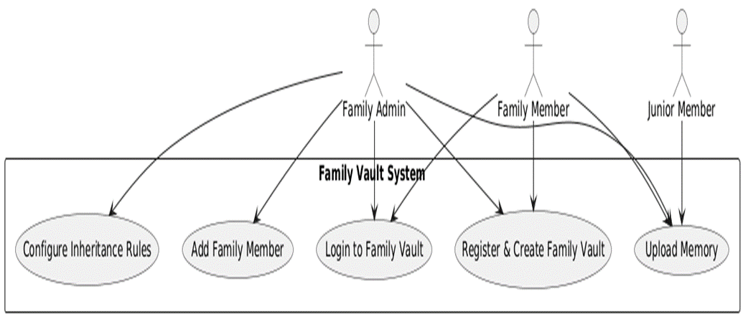

Register & Create Family Vault
Identifier |  | UC-1
Purpose |  | To allow a new user to register in the system and create a personal Family Vault, becoming the Family Administrator.
Priority |  | High
Pre-conditions |  | User has the mobile application installed.  User has a valid email address or phone number.
Post-conditions |  | User account is created and verified.  A Family Vault is created and linked to this user as Family Administrator.
Typical Course of Action
S# | Actor Action |  | System Response
1 | User selects “Sign Up”. |  | System displays registration form.
2 | User enters required details. |  | System validates fields.
3 | User submits registration. |  | System sends data to authentication service.
4 | User completes OTP/email verification. |  | System verifies identity.
5 | User enters initial family vault details. |  | System prepares vault creation.
6 | – |  | System creates Family Vault and assigns user as Admin.
7 | – |  | System redirects user to Family Vault dashboard.
Alternate Course of Action
S# | Actor Action |  | System Response
1 | User enters invalid data. |  | System highlights errors.
2 | User enters already-registered email/phone. |  | System prompts to use Login or Forgot Password.
3 | Network/server failure. |  | System shows error and aborts registration.
Table 1: UC-1

Login to Existing Family Vault
Identifier |  | UC-2
Purpose |  | Purpose: To allow a registered user to securely log in.
Priority |  | High
Pre-conditions |  | User is already registered.
Post-conditions |  | User is authenticated and session is created.
Typical Course of Action
S# | Actor Action |  | System Response
1 | User selects “Login”. |  | System shows login screen.
2 | User enters credentials. |  | System performs basic validation.
3 | User taps Login. |  | System verifies credentials via authentication service.
4 | – |  | System retrieves user profile and vault role.
5 | – |  | System logs user in and shows dashboard.
Alternate Course of Action
S# | Actor Action |  | System Response
1 | User enters wrong credentials. |  | System shows “Invalid email/phone or password”.
2 | User selects “Forgot Password” |  | System starts password recovery process.
3 | Network failure. |  | System shows network error message.

Add Family Member to Family Tree
Identifier |  | UC-3
Purpose |  | To allow the Family Admin to add a new family member and their relationship.
Priority |  | High
Pre-conditions |  | Admin is logged in.  Family Vault exists.
Post-conditions |  | New family member is added.  Relationship is stored and shown in Family Tree.
Typical Course of Action
S# | Actor Action |  | System Response
1 | Admin opens Family Tree. |  | System displays tree.
2 | Admin selects “Add Member”. |  | System shows entry form.
3 | Admin enters member details. |  | System validates details.
4 | Admin selects relationship (child/spouse/etc.). |  | System checks relation validity.
5 | Admin taps Save. |  | System sends data to backend.
6 | – |  | Backend creates the member and relationship.
7 | – |  | System refreshes Family Tree with new member.
Alternate Course of Action
S# | Actor Action |  | System Response
1 | Admin does not select a relationship. |  | System prompts “Relationship required”.
2 | Admin enters an email/phone for invitation. |  | System sends invitation.
3 | Backend error occurs. |  | System shows error and does not update the tree.

View Family Tree
Identifier |  | UC-4
Purpose |  | To allow a user to view the Family Tree structure.
Priority |  | Medium
Pre-conditions |  | User is logged in and part of a Family Vault.
Post-conditions |  | None.
Typical Course of Action
S# | Actor Action |  | System Response
1 | User opens Family Tree. |  | System fetches current tree data.
2 | – |  | System displays the tree visually.
3 | User taps a member node. |  | System shows small profile popup.
4 | User zooms or scrolls. |  | System updates tree view.
Alternate Course of Action
S# | Actor Action |  | System Response
1 | Network error. |  | System shows error and Retry option.

Upload Memory (Photo/Video/Audio/Text)
Identifier |  | UC-5
Purpose |  | To enable users to upload multimedia memories to the Family Vault.
Priority |  | High
Pre-conditions |  | User is logged in and has permission.
Post-conditions |  | Memory is created with metadata and linked to members/events.
Typical Course of Action
S# | Actor Action |  | System Response
1 | User selects “Add Memory”. |  | System shows media type options.
2 | User chooses media type and selects file/records media. |  | System shows media preview + metadata form.
3 | User enters title, description, date, tags, members. |  | System validates mandatory fields.
4 | User optionally selects an event. |  | System records event selection.
5 | User taps Upload. |  | System uploads media with progress indicator.
6 | – |  | Backend stores memory file + metadata.
7 | – |  | System confirms upload and displays new memory.
Alternate Course of Action
S# | Actor Action |  | System Response
1 | Required fields missing. |  | System highlights missing fields.
2 | Upload fails due to network. |  | System shows retry/cancel options.
3 | User cancels early. |  | System discards unsaved data.

View Memory with Access Control
Identifier |  | UC-6
Purpose |  | To let users, view memories while enforcing inheritance/access rules.
Priority |  | High
Pre-conditions |  | User is logged in; memories exist.
Post-conditions |  | None.
Typical Course of Action
S# | Actor Action |  | System Response
1 | User opens Memories or a Member Timeline.
2 | User selects a memory. |  | System fetches accessible memories.
3 | – |  | If allowed, system displays media with details.
4 | User zooms/plays media. |  | System responds (play/zoom/scroll).
Alternate Course of Action
S# | Actor Action |  | System Response
1 | Conditions not satisfied (e.g., user too young). |  | System shows “This memory will be available in the future”.
2 | Loading failure. |  | System shows error and retries options.

Configure Inheritance Rules
Identifier |  | UC-7
Purpose |  | To allow Admin/Owner to set inheritance conditions for a memory.
Priority |  | High
Pre-conditions |  | User has rights to manage memory.
Post-conditions |  | Rules are created/updated/removed.
Typical Course of Action
S# | Actor Action |  | System Response
1 | User opens a memory. |  | System shows memory details.
2 | User selects “Manage Access/Inheritance”. |  | System shows inheritance settings screen.
3 | User selects heirs from the Family Tree. |  | System displays rule conditions.
4 | User selects conditions (Always, After Date, 18th Birthday, etc.). |  | System validates rule data.
5 | User taps Save. |  | System sends rules to backend.
6 | – |  | Backend saves rules and returns success.
7 | – |  | System shows updated rule summary.
Alternate Course of Action
S# | Actor Action |  | System Response
1 | Conflicting rules. |  | System highlights conflicts and blocks saving.
2 | User removes all rules. |  | System reverts to default access permissions.
3 | Backend error. |  | System shows error and retains old rules.

Search & Filter Memories
Identifier |  | UC-8
Purpose |  | To allow users to search and filter memories.
Priority |  | Medium
Pre-conditions |  | Memories exist; user is logged in.
Post-conditions |  | None.
Typical Course of Action
S# | Actor Action |  | System Response
1 | User opens Memories page. |  | System loads memory list and search bar.
2 | User types keyword in search bar. |  | System captures input.
3 | User taps Search. |  | System queries backend.
4 | – |  | Backend returns matching memories.
5 | – |  | System shows filtered results.
6 | User opens Filters panel. |  | System displays filters (date, member, type).
7 | User selects filters. |  | System updates query.
8 | User taps Apply. |  | System displays refined results.
Alternate Course of Action
S# | Actor Action |  | System Response
1 | No matches found. |  | System shows “No memories found”.
2 | Impossible filter conditions. |  | System returns empty results.
3 | Network failure. |  | System shows error and keeps previous list.

Edit User Profile & Enable Biometric Login
Identifier |  | UC-9
Purpose |  | To allow users to update their personal profile and enable biometric login.
Priority |  | Medium
Pre-conditions |  | User is logged in; device supports biometrics.
Post-conditions |  | Profile is updated; biometric login preferences stored.
Typical Course of Action
S# | Actor Action |  | System Response
1 | User opens Profile/Settings. |  | System displays profile info and security options.
2 | User selects Edit Profile. |  | System shows editable fields.
3 | User updates details. |  | System validates fields.
4 | User taps Save. |  | System updates backend records.
5 | – |  | System shows “Profile updated”.
6 | User toggles Biometric Login ON. |  | System checks device biometric availability.
7 | User authenticates using fingerprint/Face ID. |  | System stores biometric flag for next login.
Alternate Course of Action
S# | Actor Action |  | System Response
1 | Invalid profile data. |  | System highlights issues and blocks saving.
2 | Backend update fails. |  | System shows update error; data remains unchanged.
3 | Device does not support biometrics. |  | System disables biometric toggle and shows message.
4 | User cancels biometric prompt. |  | System does not enable biometric login.

Requirements Analysis and Modeling

Entity Relationship Diagram

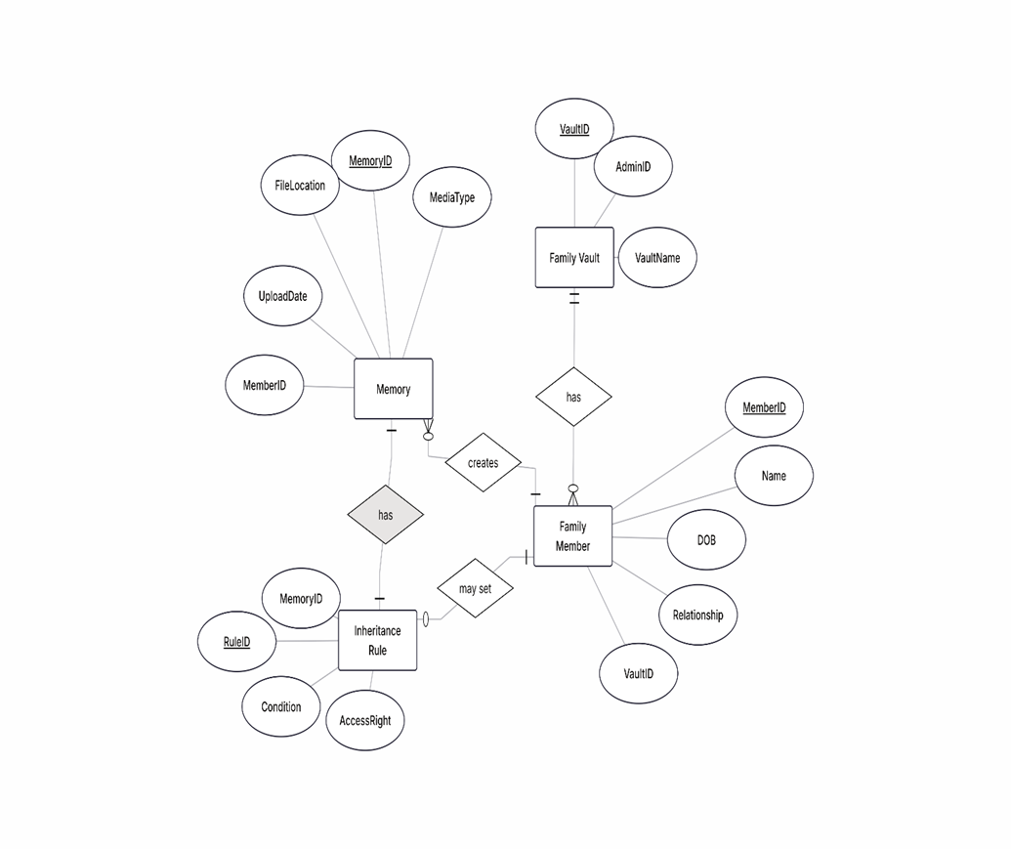

Abstract Class Diagram

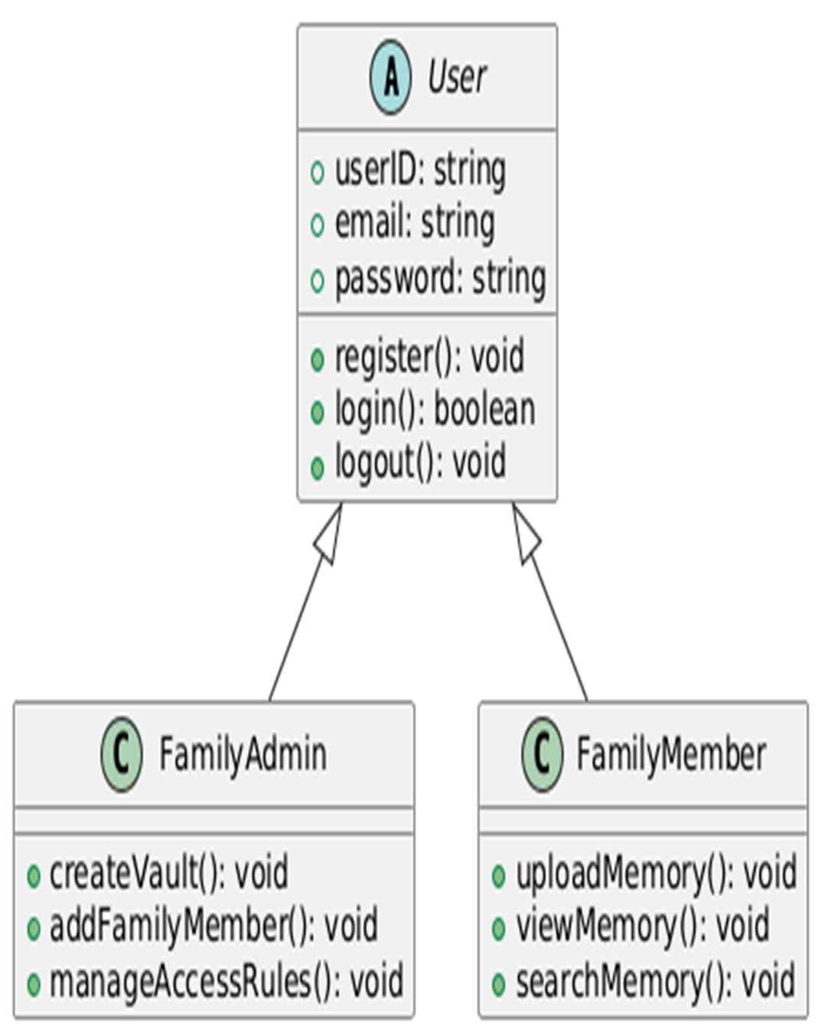

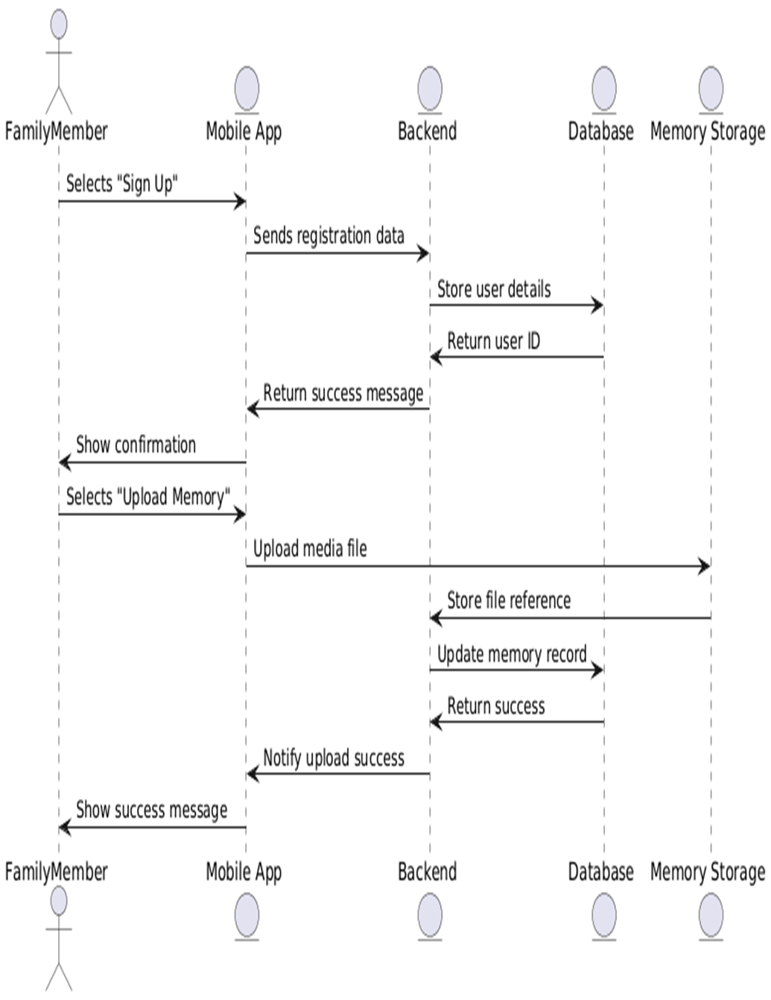
Enhanced Sequence Diagram

State Diagram

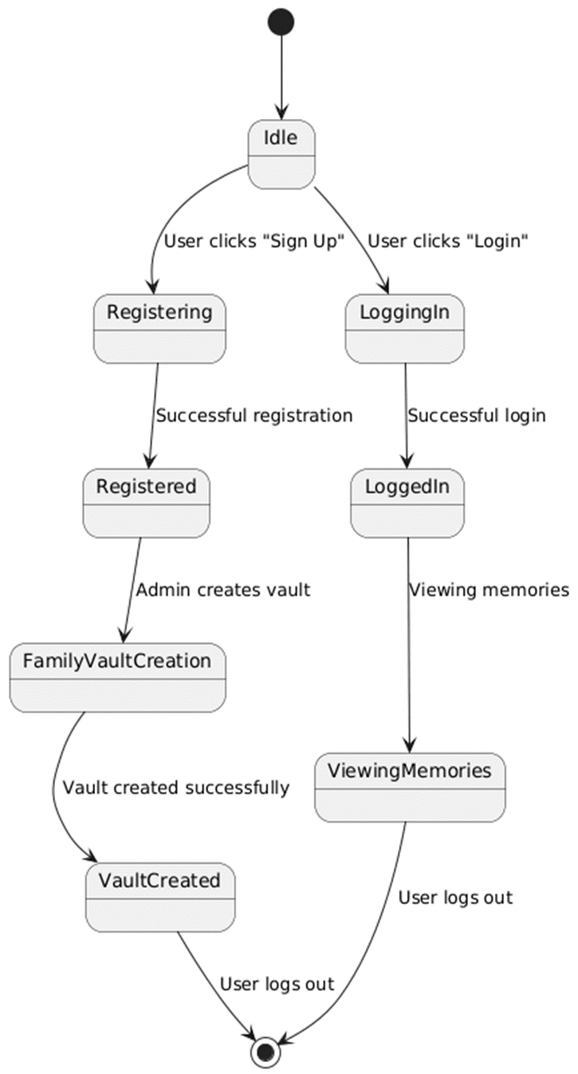

Data Flow Diagram (DFD Level 0)

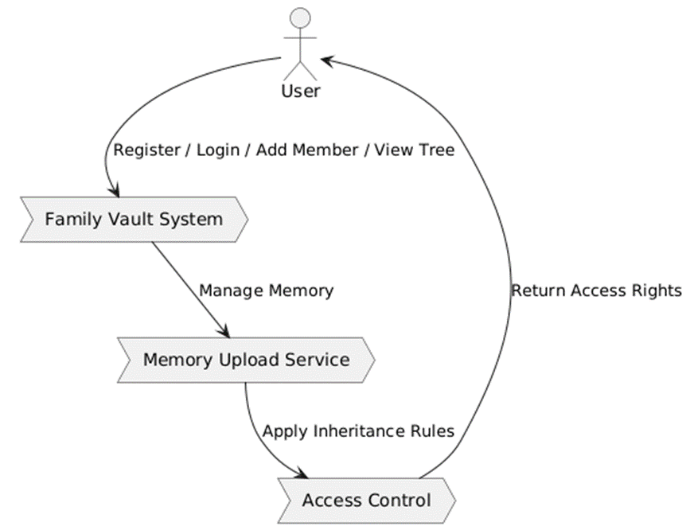

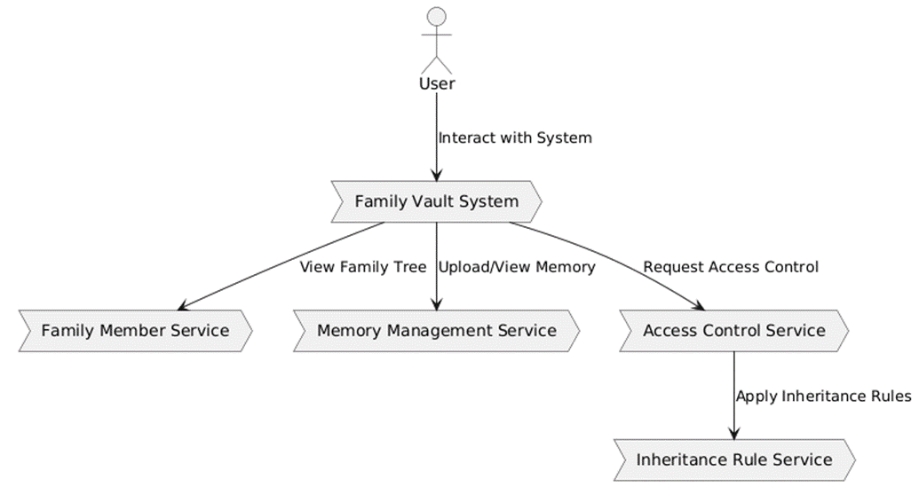
Data Flow Diagram (DFD Level 1)

Nonfunctional Requirements

Performance Requirements
- The system shall respond to basic navigation actions (switching between screens like Home, Family Tree, Memories) within 2–3 seconds under normal network conditions.
- Memory listing operations (e.g., loading a gallery of up to 50 thumbnails) shall complete within 5 seconds on a typical 4G/mobile Wi-Fi link.
- Uploading a photo up to 5 MB shall either complete within 10 seconds or present a progress indicator, so the user knows the operation is still in progress.
- The backend shall be capable of handling at least 50 concurrent requests in the FYP test environment without significant degradation in response time.
- Common queries such as “list memories for a particular family member” or “search by tag” shall return results within 3 seconds for a vault containing up to 5,000 memory items.

Safety Requirements
- The system shall require explicit confirmation from the user before permanently deleting any memory or family member from the vault.
- The system shall prevent deletion of a family member if doing so would break the basic integrity of the family tree (e.g., leaving orphan relations) without appropriate handling.
- The backend database shall be backed up periodically (according to the deployment setup) to reduce the risk of data loss in the event of a system failure.
- In case of a partial or failed upload, the system shall not make corrupted or incomplete media available to any user; instead, it shall mark or delete such entries safely.

Security Requirements
- All user authentication shall be handled via secure channels using HTTPS.
- User credentials (passwords) shall never be stored in plain text; they shall be handled by Firebase Authentication or securely hashed if stored in the project’s database.
- Access to each memory shall be checked against both role-based permissions (e.g., administrator vs. normal member) and rule-based inheritance settings.
- Sensitive operations such as changing inheritance rules, deleting members, or modifying vault settings shall require a higher level of verification (such as password re-entry or biometric confirmation on supported devices).
- The system shall ensure that one family’s vault data is never accessible to another family’s users.
- Logs of sensitive administrative actions (like mass deletion) should be available for system monitoring (at least in simple form for FYP).

Additional Software Quality Attributes
- Usability:
The user interface shall be simple, consistent, and easy to learn. Icons and labels shall be selected with clear meaning. Onboarding screens or tooltips shall be used to explain new concepts to users.
- Reliability:
The system shall handle network interruptions gracefully. For example, if a request fails, meaningful error messages and retry options must be provided. Data corruption must be minimized by ensuring atomic operations and appropriate error handling.
- Maintainability:
The system shall be developed using modular design principles, where UI, business logic, and data access are separated. Code should be documented and follow consistent naming conventions and project structure, so future developers (or even the same team later) can extend the system.
- Portability:
As a Flutter application, the codebase shall be structured in a way that allows relatively easy deployment on both Android and iOS platforms with minimal platform-specific changes.
- Scalability (limited FYP scope):
While the system is not expected to handle millions of users in the FYP phase, the design choices (NoSQL database, stateless APIs) should allow the system to grow with more resources if needed in the future.

Other Requirements
Other requirements may include:
- Database Design Requirements:
Using collections in MongoDB for users, family members, vaults, memories, inheritance rules, and events. Appropriate indexing must be considered for common queries.
- External Interface Requirements:
RESTful APIs must be documented clearly, specifying endpoints, request/response formats, and error codes.
- Legal and Ethical Requirements:
Even at academic scale, the system should avoid storing illegal content and should present basic terms explaining that users are responsible for what they upload. The system should respect privacy and allow users to request account deletion.

Revised Project Plan

Project Initiation:
- Tasks: Forming the team, finalizing the project title, scope, and initial research and requirements gathering.
- Duration: 2 weeks
- Completion Date: November 30, 2025

Requirement Analysis and System Design:
- Tasks: Defining system requirements, creating system architecture, database design, and family tree design.
- Duration: 4 weeks
- Completion Date: December 30, 2025

Backend Development (Node.js + MongoDB):
- Tasks: Develop and integrate RESTful APIs, set up the database schema, implement user authentication and security features.
- Duration: 6 weeks
- Completion Date: February 15, 2026

Frontend Development (Flutter App):
- Tasks: Design the mobile app interface, implement memory upload, user authentication, and family tree visualization.
- Duration: 8 weeks
- Completion Date: April 15, 2026

Integration and Testing:
- Tasks: Integration of front-end and back-end, system testing, performance optimization, security testing.
- Duration: 6 weeks
- Completion Date: May 30, 2026

Deployment and Final Presentation:
- Tasks: Deploy the application to Firebase, prepare user documentation, and deliver the final project presentation.
- Duration: 2 weeks
- Completion Date: June 15, 2026

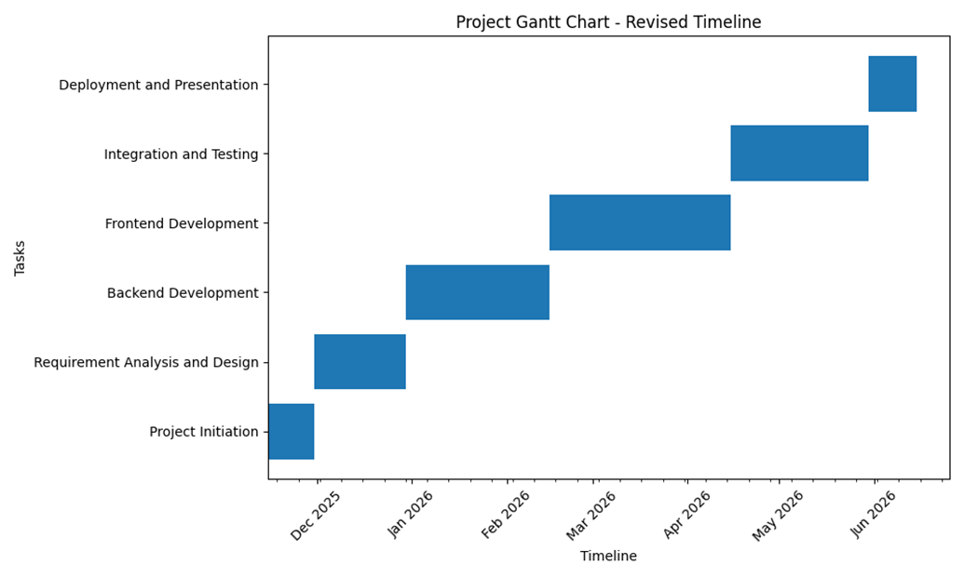

References
- Pressman, R. S., & Maxim, B. R., Software Engineering: A Practitioner’s Approach.
- Sommerville, I., Software Engineering.
- Official documentation for Flutter, Node.js, MongoDB, and Firebase.
- Research articles on digital legacy, family heritage, and digital preservation (you can add specific papers later).

Appendix A: Glossary
The following is a glossary for the Family Digital Heritage Vault project. It defines key terms, acronyms, and abbreviations used in the project documentation, including functional and technical terminology that is important for interpreting the Software Requirements Specification (SRS).

Key Terms and Definitions:
- Family Digital Heritage Vault (FDHV): A secure, cloud-based platform designed to help families preserve, organize, and pass down their digital memories, such as photos, videos, audio messages, and written stories.
- Family Vault: A private storage space within the FDHV system where family members can upload, organize, and share multimedia memories. The vault is associated with a primary administrator (typically the family organizer).
- Family Tree: A visual representation of the relationships between family members. It links individuals in the system and associates’ memories with specific family members based on their relationship (e.g., parent, child, sibling).
- Heir-Based Access Control: A system feature that allows specific memories or content to be accessible only by designated heirs or family members under predefined conditions, such as age or relationship status.
- Inheritance Rules: Rules set by family members or administrators that dictate when and how specific memories become accessible to other family members. For example, a memory may only be visible to a child after they turn 18.
- Biometric Authentication: A method of verifying the identity of users based on unique biological characteristics such as fingerprints, face recognition, or voice patterns. It is used for secure login and protecting sensitive data.
- Multimedia Memory Management: The process of handling various types of media files (e.g., photos, videos, audio messages) and linking them to family members and life events within the family vault.
- Event-Based Notifications: Automated alerts sent to users based on significant family events, such as birthdays, anniversaries, or the addition of new memories. These notifications help maintain family engagement and tradition.
- Cloud Storage: A remote data storage solution that allows families to store and access their memories securely over the internet, using cloud services such as Firebase or MongoDB.
- MongoDB: A NoSQL database used for storing family data and multimedia content in a scalable, flexible manner. MongoDB allows for dynamic and hierarchical data storage, making it suitable for the Family Digital Heritage Vault’s needs.
- Firebase: A cloud-based platform used for user authentication, real-time data storage, and notifications within the Family Digital Heritage Vault. Firebase integrates with both mobile and web applications.
- User Roles: Various user types within the Family Digital Heritage Vault system, including:
  - Family Administrator: The primary user responsible for managing the family vault, inviting members, and setting inheritance rules.
  - Family Member: A user who can upload, view, and interact with memories in the vault.
  - Heir: A family member who is granted access to certain memories based on inheritance rules.
  - Junior Family Member: A child or teen family member with restricted access to specific memories.
  - System Administrator: A platform-level user responsible for managing overall system health, security, and data integrity.
- RESTful APIs: A set of web services that allow communication between the front-end (mobile or web) and the back-end (server-side). The APIs are used to manage user authentication, memory uploads, family tree management, and inheritance rule enforcement.
- Encryption: The process of converting sensitive data into a format that is unreadable without the proper decryption key. This ensures that family memories stored in the vault are protected from unauthorized access.
- Access Control: A security feature that restricts who can view or interact with specific content in the Family Digital Heritage Vault. It is enforced through roles (e.g., Admin, Family Member, Heir) and inheritance rules.

Appendix B: IV & V Report
(Independent verification & validation)
IV & V Resource

Name Signature

S# | Defect Description | Origin Stage | Status | Fix Time
 |  |  |  | Hours | Minutes
1
2
3
…
Table 3: List of non-trivial defects

